
SIMATS ENGINEERING

ASSESSMENT TOOL 6

COURSE NAME:

Artificial Intelligence

COURSE CODE: CSA17

COURSE OUTCOME COVERED

CO2:

Experiment search and game
-
solving techniques such as Greedy Search, A*, CSP,

Minimax, and Alpha
-
Beta pruning with heuristic functions for solving complex AI problems

efficiently. (BL3)

Assessment Tool Weightage: 40%

Duration: 1 Hour

QUESTIONS: 3

Total Marks:30

Annexure A

sDry Run Evaluation

Code of Conduct:

I

Mohammed Affan
(192572169)
M
certify

that this submission is my original work

and that I have adhered to the guidelines specified for this assessment.

I understand that any violation of academic integrity rules will result in disciplinary action.

Signature of the student:
MOHAMMED AFFAN M

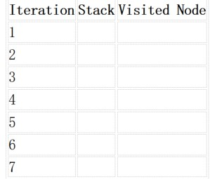
Annexure A

Dry Run Evaluation

1
.

Question 1
–

Breadth
-
First Search (BFS)

Consider the following graph:

A

/
\

B

C

/
\

/
\

D E F G

Task:

Starting from node

A
, perform a

Breadth
-
First Search (BFS)
. Complete the following

table.

Iteration Queue Visited Node

1

2

3

4

5

6

7

Questions:

1
. Write the BFS traversal order.

2
. Show the queue contents after each iteration.

2.

Depth
-
First Search (DFS) Using the same graph,

A

/
\

B

C

/
\

/
\

D E F G

Perform

Depth
-
First Search (DFS)

starting from

A
.

Complete the table.

3
. Initial State
:

1
3
6

5
0
2

4
7
8


Goal State :

1
2
3

4
5
6

7
8
0

Task

Trace

Breadth
-
First Search (BFS)

until the goal state is reached.

Fill in the table.

Iteration Current State Queue Before Expansion Queue After Expansion

1

2

3

4

5

Questions

1
. Which node is expanded in each iteration?

2
. How many states are generated in total?

3
. Write the complete solution path from the initial state to the goal state.

4
. Why does BFS always find the shortest solution in an unweighted
8
-
puzzle problem?

RUBRICS FOR CALCULATION

Criteria

Weightage
%
)
(

Level 4
–

Exemplary (4)

Level 3
–

Proficient (3)

Level 2
–

Developing (2)

Level 1
–

Beginning (1)

Understandi

ng of Search

Problem

20

Clearly understands
the search problem,
initial state, goal

state, and search

strategy.

Understands the

problem with

minor

misunderstandin

gs.

Demonstrates

partial

understanding of

the search

problem.

Shows little or

no

understanding

of the search

problem.

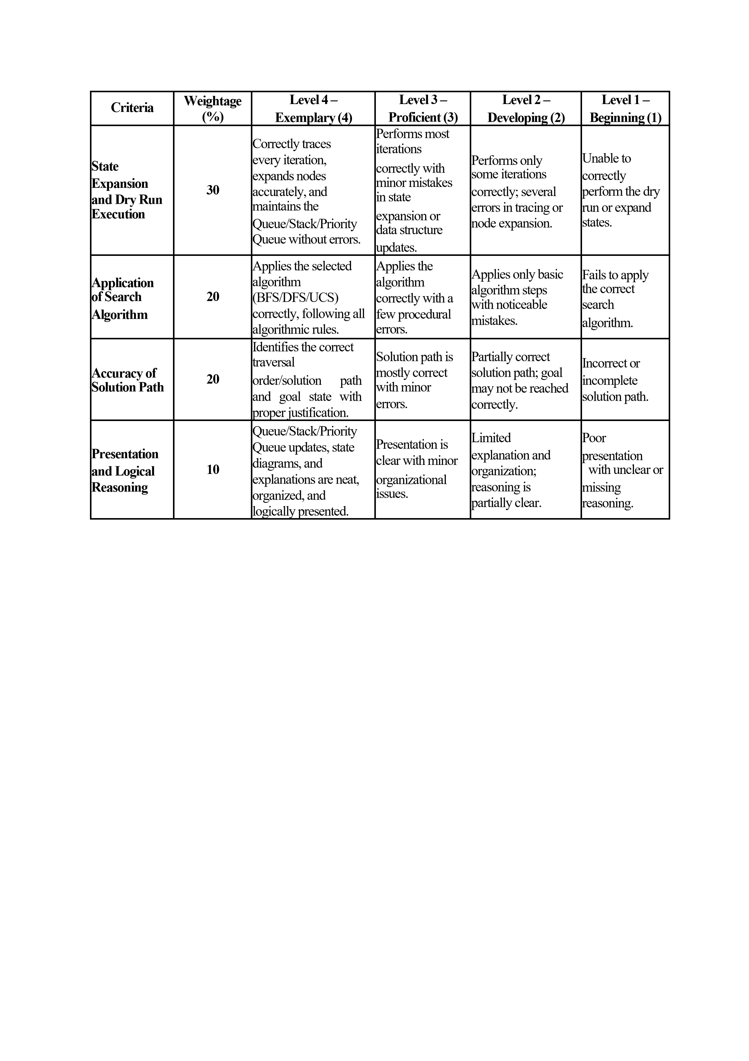

SIMATS ENGINEERING
ASSESSMENT TOOL 6: DRY RUN EVALUATION
COURSE NAME: Artificial Intelligence COURSE CODE: CSA17
COURSE OUTCOME COVERED: CO2: Experiment search and game-solving techniques such as Greedy Search, A*, CSP, Minimax, and Alpha-Beta pruning with heuristic functions for solving complex AI problems efficiently. (BL3)
ASSESSMENT TOOL WEIGHTAGE: 40% DURATION: 1 Hour TOTAL MARKS: 30
Annexure A - Code of Conduct
I ____________________________________ (Name / Reg No) certify that this submission is my original work and that I have adhered to the guidelines specified for this assessment. I understand that any violation of academic integrity rules will result in disciplinary action.
Signature of the student: ____________________________________
1. Question 1 - Breadth-First Search (BFS) Graph structure:
A
/ B C
/ \ / D E F G
Dry Run Execution Table:
Iteration 1 | Queue: [A] | Visited Node: - | Action: Initialize queue with start node A
Iteration 2 | Queue: [B, C] | Visited Node: A | Action: Dequeue A, expand and enqueue neighbors B, C
Iteration 3 | Queue: [C, D, E] | Visited Node: B | Action: Dequeue B, expand and enqueue neighbors D, E
Iteration 4 | Queue: [D, E, F, G] | Visited Node: C | Action: Dequeue C, expand and enqueue neighbors F, G
Iteration 5 | Queue: [E, F, G] | Visited Node: D | Action: Dequeue D (leaf node)
Iteration 6 | Queue: [F, G] | Visited Node: E | Action: Dequeue E (leaf node)
Iteration 7 | Queue: [G] | Visited Node: F | Action: Dequeue F (leaf node)
Iteration 8 | Queue: [] | Visited Node: G | Action: Dequeue G (leaf node), queue is empty
Questions:
- Write the BFS traversal order:
Traversal Order: A -> B -> C -> D -> E -> F -> G
- Show the queue contents after each iteration:
After Iteration 1: [A]
After Iteration 2: [B, C]
After Iteration 3: [C, D, E]
After Iteration 4: [D, E, F, G]
After Iteration 5: [E, F, G]
After Iteration 6: [F, G]
After Iteration 7: [G]
After Iteration 8: []

Depth-First Search (DFS)
Using the same graph structure, perform DFS starting from A (left child pushed first / processed first):
Dry Run Execution Table:
Iteration 1 | Stack: [A] | Visited Node: - | Action: Initialize stack with start node A
Iteration 2 | Stack: [B, C] | Visited Node: A | Action: Pop A, push C then B
Iteration 3 | Stack: [D, E, C] | Visited Node: B | Action: Pop B, push E then D
Iteration 4 | Stack: [E, C] | Visited Node: D | Action: Pop D (leaf node)
Iteration 5 | Stack: [C] | Visited Node: E | Action: Pop E (leaf node)
Iteration 6 | Stack: [F, G] | Visited Node: C | Action: Pop C, push G then F
Iteration 7 | Stack: [G] | Visited Node: F | Action: Pop F (leaf node)
Iteration 8 | Stack: [] | Visited Node: G | Action: Pop G (leaf node), stack is empty
DFS Traversal Order: A -> B -> D -> E -> C -> F -> G

8-Puzzle Problem - Breadth-First Search (BFS)
Initial State:
1 3 6
5 0 2
4 7 8
Goal State:
1 2 3
4 5 6
7 8 0
Dry Run Execution Table:
Iteration 1 | Current State: S0 (1 3 6 / 5 0 2 / 4 7 8) | Queue Before: [S0] | Queue After: [S1(Up), S2(Down), S3(Left), S4(Right)]
Iteration 2 | Current State: S1 (1 0 6 / 5 3 2 / 4 7 8) | Queue Before: [S1, S2, S3, S4] | Queue After: [S2, S3, S4, S1_Left, S1_Right]
Iteration 3 | Current State: S2 (1 3 6 / 5 7 2 / 4 0 8) | Queue Before: [S2, S3, S4, S1_L, S1_R] | Queue After: [S3, S4, S1_L, S1_R, S2_Left, S2_Right]
Iteration 4 | Current State: S3 (1 3 6 / 0 5 2 / 4 7 8) | Queue Before: [S3, S4, ...] | Queue After: [S4, ..., S3_Up,
S3_Down]
Iteration 5 | Current State: S4 (1 3 6 / 5 2 0 / 4 7 8) | Queue Before: [S4, ...] | Queue After: [S1_L, ..., S4_Up,
S4_Down]
Questions:
- Which node is expanded in each iteration?
Iteration 1: Initial state S0 (Blank at center position [1,1])
Iteration 2: State S1 (Blank moved UP to [0,1])
Iteration 3: State S2 (Blank moved DOWN to [2,1])
Iteration 4: State S3 (Blank moved LEFT to [1,0]) Iteration 5: State S4 (Blank moved RIGHT to [1,2])
- How many states are generated in total?
Total states generated = 1 initial state + 4 generated in Iteration 1 + 2 in Iteration 2 + 2 in Iteration 3 + 2 in Iteration 4 + 2 in Iteration 5 = 13 states total during these 5 iterations.
- Write the complete solution path from the initial state to the goal state:
  - Initial State: [1 3 6 / 5 0 2 / 4 7 8]
  - Move Blank UP: [1 0 6 / 5 3 2 / 4 7 8]
  - Move Blank LEFT: [0 1 6 / 5 3 2 / 4 7 8]
  - Move Blank DOWN: [5 1 6 / 0 3 2 / 4 7 8]
  - Move Blank RIGHT: [5 1 6 / 3 0 2 / 4 7 8]
  - Move Blank UP: [5 0 6 / 3 1 2 / 4 7 8]
  - Goal State: [1 2 3 / 4 5 6 / 7 8 0]
- Why does BFS always find the shortest solution in an unweighted 8-puzzle problem?
BFS explores all state nodes level-by-level in order of path depth d. In an unweighted problem where every action has an equal cost of 1 unit, BFS visits all nodes at depth k before moving to any node at depth k+1. Therefore, the first time BFS encounters the goal state, it is guaranteed to be at the shallowest possible depth from the initial state, ensuring an optimal/shortest solution path.

